**Create a Doctor Account**

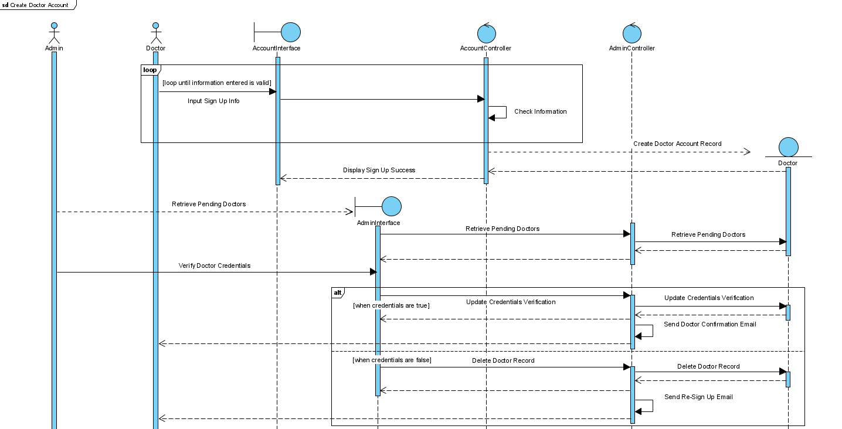

**Manage Doctor’s Profile**

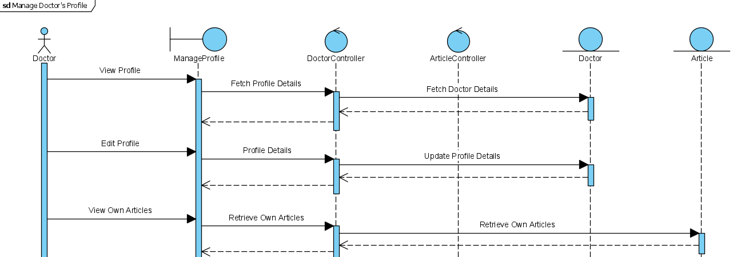

**Create Interested Party Account**

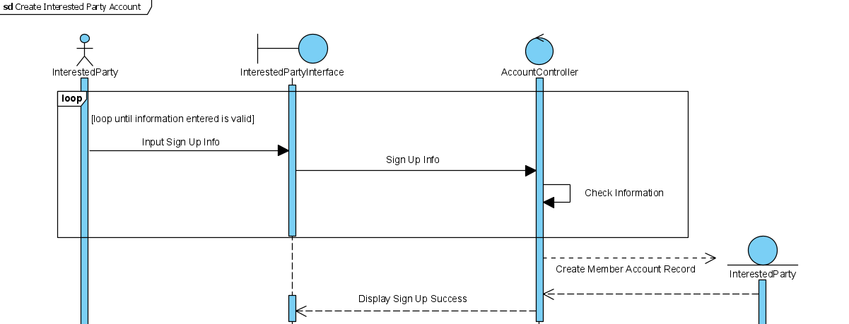

**Manage Interested Party’s Profile**

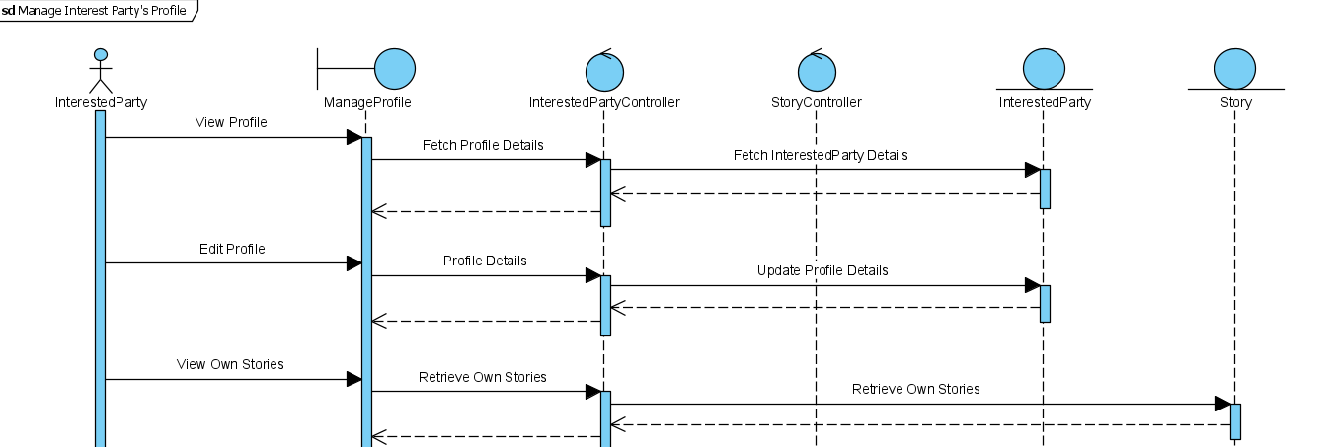

**Interacting with Lung Cancer / Smoking Articles**

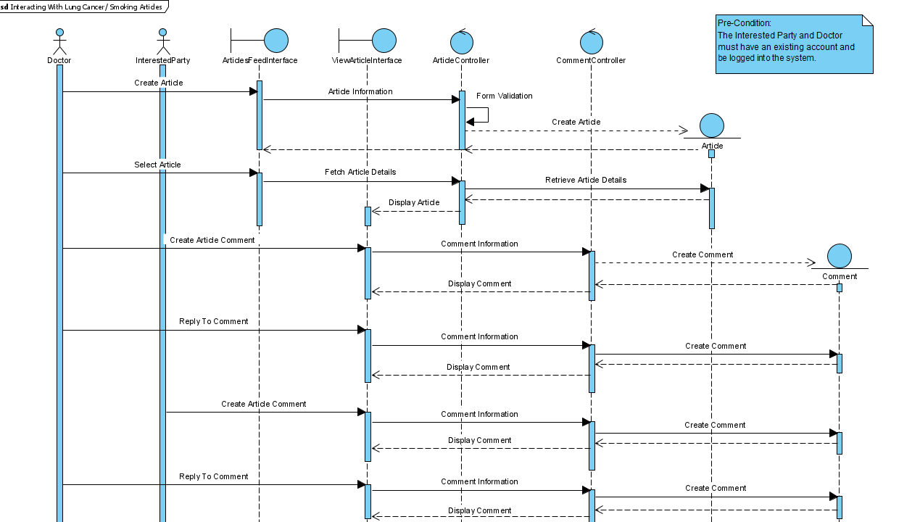

**Regulating Lung Cancer / Smoking Articles**

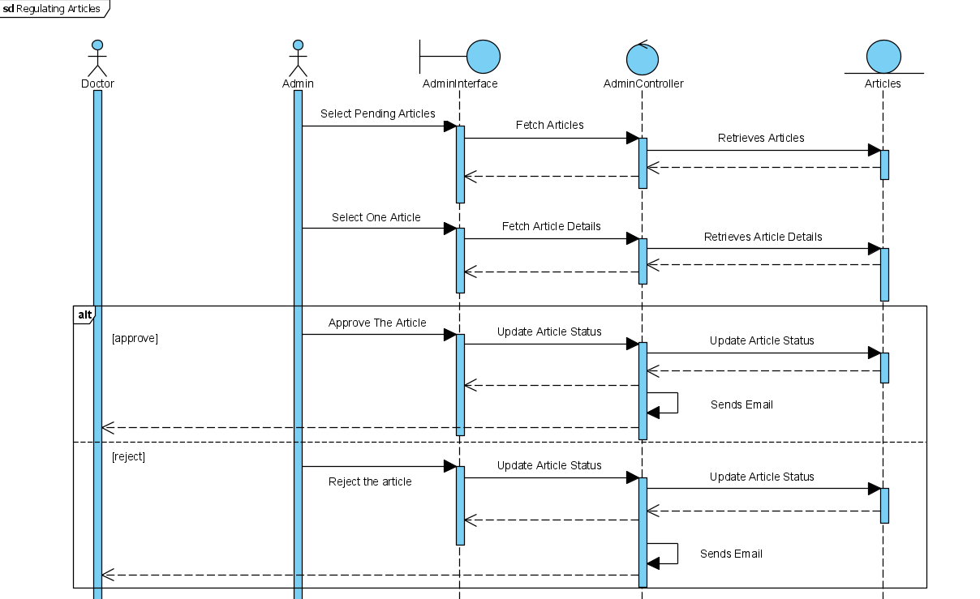

**Interact with Personal Stories**

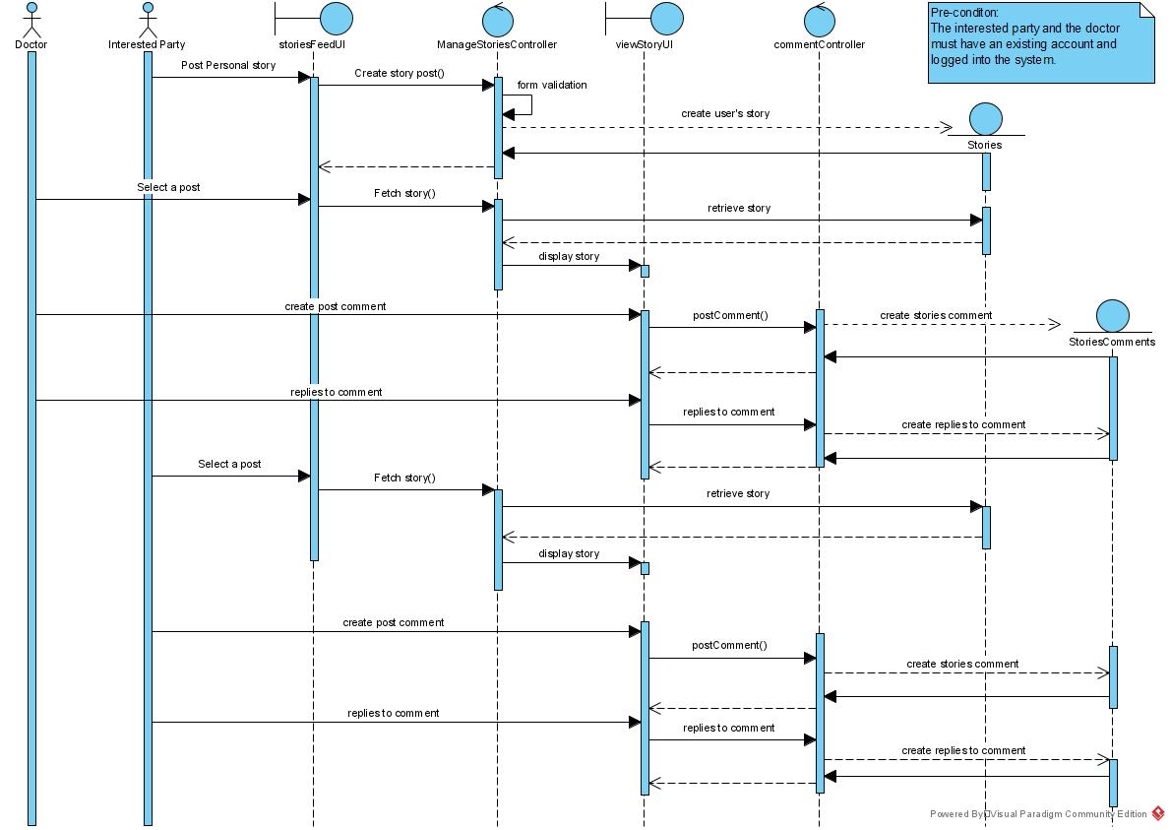

**Inform System Status to Users**

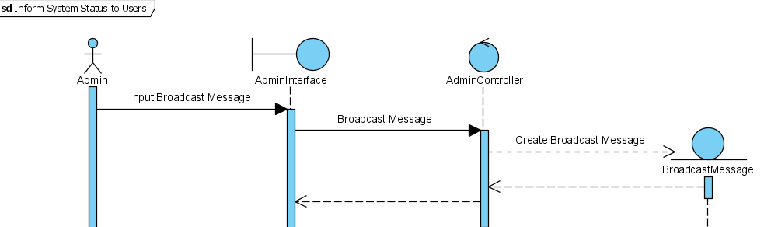

**Track Quit Smoking Progression**

